🔷 1. What is Generative AI?
Generative AI focuses on creating new data that resembles real data.
👉 Examples:
- Generate images (Stable Diffusion, DALL·E)
- Generate text (GPT models)
- Generate music, video, code
👉 Core idea:
Instead of learning P(y | x) (predict labels), it learns:
$$P(x)$$
➡️ The distribution of the data itself

🔷 2. Types of Generative Models

🟢 2.1 Variational Autoencoders (VAEs)
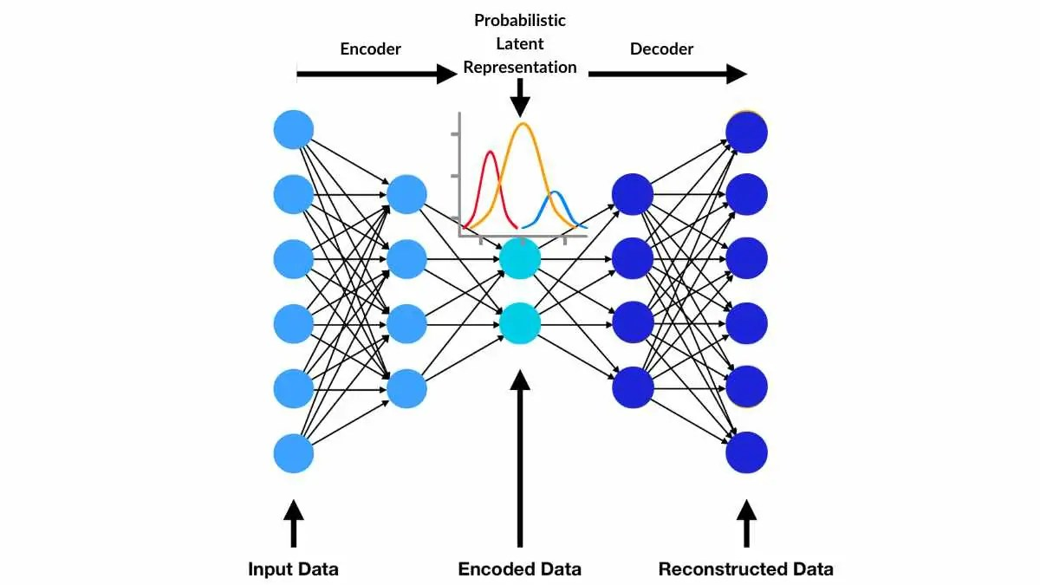
🔹 Concept
A probabilistic autoencoder that learns a compressed representation of data.
🔹 Architecture
Input → Encoder → Latent Space → Decoder → Output
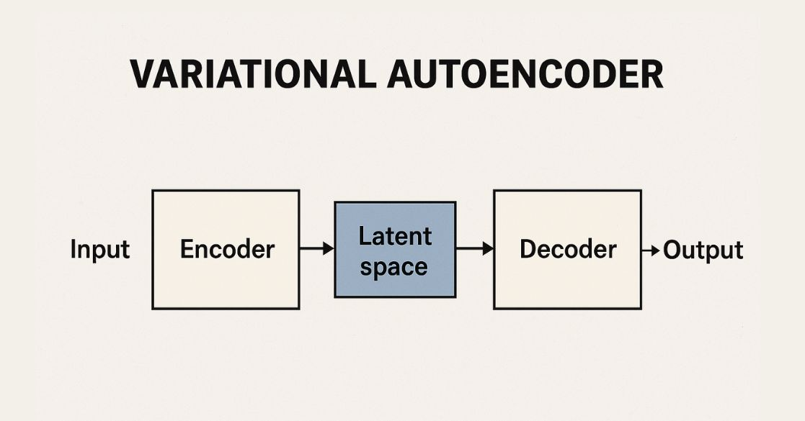
- Encoder → compresses input into mean (μ) and variance (σ)
- Latent space → sampled using Gaussian distribution
- Decoder → reconstructs data
🔹 Key Idea
Instead of fixed encoding:
$$z∼N(μ,σ^{2})$$

🔹 Loss Function
Two parts:
- Reconstruction Loss (how close output is to input)
- KL Divergence (regularization)
$$Loss=Reconstruction+KLDivergence$$

🔹 Advantages
✔ Stable training
✔ Smooth latent space
✔ Good for representation learning

🔹 Limitations
❌ Blurry outputs
❌ Less sharp images compared to GANs

🔹 Use Cases
- Image denoising (like your autoencoder project)
- Anomaly detection
- Data compression

🔴 2.2 Generative Adversarial Networks (GANs)
🔹 Concept
Two networks compete:
- Generator (G) → creates fake data
- Discriminator (D) → detects real vs fake

🔹 Architecture
Noise → Generator → Fake Image
↓
Discriminator → Real / Fake

🔹 Objective Function
$$\underset{G}{min⁡}\underset{D}{max⁡}V(D,G)$$
- Generator tries to fool discriminator
- Discriminator tries to detect fake

🔹 Advantages
✔ Very sharp, realistic images
✔ State-of-the-art for image generation

🔹 Limitations
❌ Training instability
❌ Mode collapse (same outputs repeatedly)
❌ Hard to tune

🔹 Variants
- DCGAN
- CycleGAN
- StyleGAN (used in face generation)

🔹 Use Cases
- Deepfakes
- Image super-resolution
- Image-to-image translation

🔵 2.3 Diffusion Models
🔹 Concept (Modern SOTA)
Generate data by gradually removing noise

🔹 Forward Process (Noise Addition)
$$x_{0}→x_{1}→x_{2}→...→x_{T}$$
Data becomes pure noise

🔹 Reverse Process (Generation)
$$x_{T}→x_{T-1}→...→x_{0}$$
Model learns to denoise step-by-step

🔹 Key Idea
Model learns:
$$P(x_{t-1}∣x_{t})$$

🔹 Advantages
✔ Extremely high-quality outputs
✔ Stable training
✔ Better diversity than GANs

🔹 Limitations
❌ Very slow generation
❌ Computationally expensive
❌ Requires large data

🔹 Use Cases
- Image generation (Stable Diffusion)
- Text-to-image models
- Video generation

🔷 3. Comparison of Models
Feature | VAE | GAN | Diffusion
Output Quality | Medium | High | Very High
Training Stability | High | Low | High
Speed | Fast | Medium | Slow
Diversity | Good | Medium | Excellent
Complexity | Low | High | Very High

🔷 4. Performance Metrics
Evaluating generative models is tricky because there's no single correct output.

🔹 4.1 FID (Fréchet Inception Distance)
Measures similarity between real and generated images
$$FID↓=Better$$
✔ Lower FID → realistic images

🔹 4.2 IS (Inception Score)
Measures:
- Image quality
- Diversity
$$IS↑=Better$$

🔹 4.3 PSNR (Peak Signal-to-Noise Ratio)
Used in:
- Denoising (your project)
- Image reconstruction
$$PSNR↑=Betterquality$$

🔹 4.4 SSIM (Structural Similarity Index)
Measures:
- Structural similarity between images
$$SSIM↑=Better$$

🔹 4.5 Log-Likelihood / ELBO (for VAEs)
Measures probability of generated data

🔷 5. Limitations of Generative AI

⚠️ 5.1 Data Dependency
- Needs large datasets
- Poor data → poor generation

⚠️ 5.2 Bias & Fairness
- Learns bias from data
- Can generate harmful content

⚠️ 5.3 Computational Cost
- Diffusion models → expensive
- Training large models needs GPUs

⚠️ 5.4 Evaluation Difficulty
- No exact ground truth
- Metrics don’t fully capture quality

⚠️ 5.5 Ethical Issues
- Deepfakes
- Misinformation
- Copyright concerns

⚠️ 5.6 Mode Collapse (GANs)
- Limited variety of outputs

🔷 6. Real-World Applications

🧠 In AI/ML Industry
- Synthetic data generation
- Data augmentation
- Medical imaging

🎨 Creative AI
- Art generation
- Music composition
- Video creation

🏥 Healthcare
- MRI reconstruction
- Disease detection

🛒 Business
- Product design
- Personalized marketing

